B. SAI MANOJ KUMAR
192411251
INTERNET PROGRAMING-CSA4308

LAB PROGRAMS
EXPERIMENT-6:

<!DOCTYPE html>
<html lang="en">
<head>
<meta charset="UTF-8">
<meta name="viewport" content="width=device-width, initial-scale=1.0">
<title>Sweet Cake Online Ordering</title>

<style>
*{
margin:0;
padding:0;
box-sizing:border-box;
font-family:Arial, sans-serif;
}

body{
background:#fff8f9;
}

header{
background:#c2185b;
color:white;
text-align:center;
padding:25px;
}

nav{
background:#880e4f;
text-align:center;
padding:15px;
position:sticky;
top:0;
}

nav a{
color:white;
text-decoration:none;
margin:15px;
font-size:17px;
}

nav a:hover{
color:#ffd54f;
}

.hero{
background:#f8bbd0;
padding:70px 20px;
text-align:center;
}

.hero h1{
color:#880e4f;
margin-bottom:10px;
}

.hero p{
color:#5d1049;
font-size:18px;
}

.search{
width:90%;
max-width:950px;
background:white;
margin:25px auto;
padding:20px;
border-radius:12px;
box-shadow:0 4px 10px rgba(0,0,0,0.15);
}

form{
display:grid;
grid-template-columns:repeat(auto-fit,minmax(180px,1fr));
gap:15px;
}

input,select{
padding:12px;
font-size:15px;
border:1px solid #ddd;
border-radius:6px;
}

button{
background:#c2185b;
color:white;
border:none;
padding:12px;
border-radius:6px;
cursor:pointer;
transition:0.3s;
}

button:hover{
background:#880e4f;
}

.section{
padding:35px;
}

.cards{
display:flex;
flex-wrap:wrap;
justify-content:center;
gap:20px;
}

.card{
background:white;
width:240px;
border-radius:12px;
box-shadow:0 3px 8px rgba(0,0,0,0.15);
text-align:center;
padding:18px;
transition:transform 0.3s;
}

.card:hover{
transform:translateY(-5px);
}

.card img{
width:100%;
height:160px;
object-fit:cover;
border-radius:10px;
}

.card h3{
color:#c2185b;
margin:12px 0;
}

.card p{
margin-bottom:10px;
}

.section ul{
line-height:2;
padding-left:20px;
}

footer{
background:#880e4f;
color:white;
text-align:center;
padding:18px;
margin-top:20px;
}
</style>
</head>

<body>

<header>
<h1>Sweet Cake Online Ordering</h1>
<p>Freshly Baked Cakes Delivered with Love</p>
</header>

<nav>
<a href="#">Home</a>
<a href="#">Cakes</a>
<a href="#">Order</a>
<a href="#">Cart</a>
<a href="#">Login</a>
<a href="#">Register</a>
<a href="#">Contact</a>
</nav>

<section class="hero">
<h1>Celebrate Every Moment with Delicious Cakes</h1>
<p>Birthday | Wedding | Anniversary | Custom Cakes</p>
</section>

<div class="search">
<h2>Find Your Favorite Cake</h2>
<br>

<form>
<input type="text" placeholder="Enter Cake Name">

<select>
<option>Choose Category</option>
<option>Birthday Cake</option>
<option>Chocolate Cake</option>
<option>Fruit Cake</option>
<option>Wedding Cake</option>
</select>

<select>
<option>Select Price Range</option>
<option>$10 - $20</option>
<option>$20 - $40</option>
<option>$40 - $60</option>
</select>

<button type="submit">Search</button>
</form>
</div>

<section class="section">
<h2 align="center">Popular Cakes</h2>
<br>

<div class="cards">

<div class="card">
<img src="https://images.unsplash.com/photo-1578985545062-69928b1d9587?w=400" alt="Chocolate Cake">
<h3>Chocolate Cake</h3>
<p><b>Price:</b> $20</p>
<button>Add to Cart</button>
</div>

<div class="card">
<img src="https://images.unsplash.com/photo-1563729784474-d77dbb933a9e?w=400" alt="Vanilla Cake">
<h3>Vanilla Cake</h3>
<p><b>Price:</b> $18</p>
<button>Add to Cart</button>
</div>

<div class="card">
<img src="https://images.unsplash.com/photo-1621303837174-89787a7d4729?w=400" alt="Red Velvet Cake">
<h3>Red Velvet Cake</h3>
<p><b>Price:</b> $25</p>
<button>Add to Cart</button>
</div>

<div class="card">
<img src="https://images.unsplash.com/photo-1464349095431-e9a21285b5f3?w=400" alt="Fruit Cake">
<h3>Fruit Cake</h3>
<p><b>Price:</b> $22</p>
<button>Add to Cart</button>
</div>

</div>
</section>

<section class="section">
<h2>User Features</h2>
<ul>
<li>✔ User Registration & Login</li>
<li>✔ Search and Filter Cakes</li>
<li>✔ View Cake Details</li>
<li>✔ Add Cakes to Cart</li>
<li>✔ Place Online Orders</li>
<li>✔ Manage Shipping Address</li>
<li>✔ Track Order Status</li>
<li>✔ View Order History</li>
</ul>
</section>

<section class="section">
<h2>Administrator Features</h2>
<ul>
<li>✔ Secure Admin Login</li>
<li>✔ Manage Cake Products</li>
<li>✔ Add and Update Cake Details</li>
<li>✔ Upload Product Images</li>
<li>✔ Manage Customer Orders</li>
<li>✔ Update Delivery Status</li>
<li>✔ Shipping & Delivery Management</li>
<li>✔ Admin Logout</li>
</ul>
</section>

<section class="section">
<h2>Contact Us</h2>
<p><b>Email:</b> support@sweetcake.com</p>
<p><b>Phone:</b> +1 9876543210</p>
<p><b>Address:</b> Sweet Cake Shop, Main Street</p>
</section>

<footer>
<p>© 2026 Sweet Cake Online Ordering | All Rights Reserved</p>
</footer>

</body>
</html>
OUTPUT:
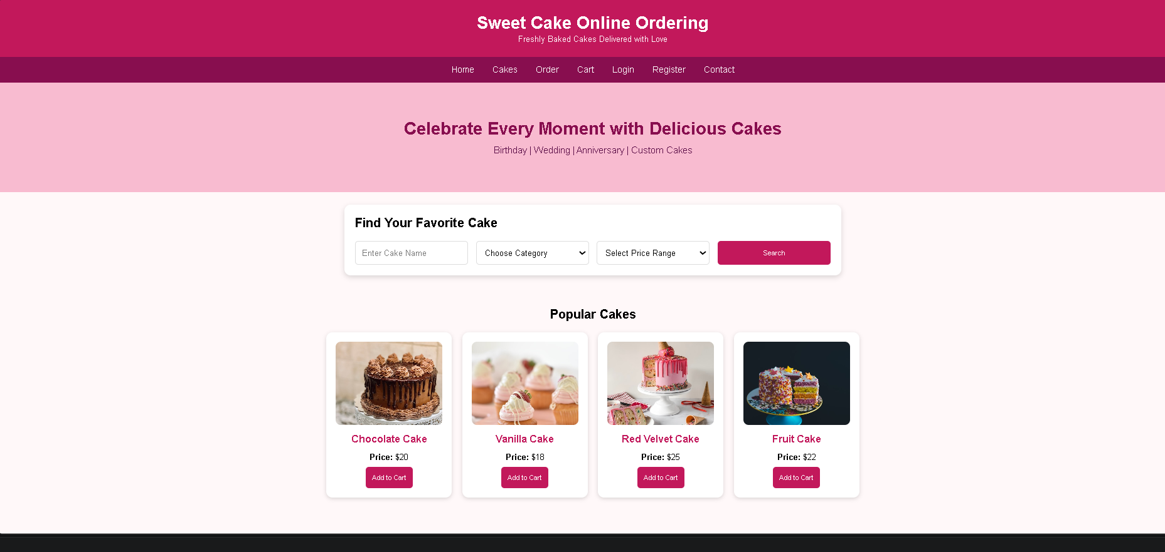

EXPERIMENT-7:
<!DOCTYPE html>
<html lang="en">
<head>
<meta charset="UTF-8">
<meta name="viewport" content="width=device-width, initial-scale=1.0">
<title>Beauty Parlour Appointment Booking System</title>

<style>
*{
margin:0;
padding:0;
box-sizing:border-box;
font-family:Arial, sans-serif;
}

body{
background:#f6f3ff;
}

header{
background:#6a1b9a;
color:white;
text-align:center;
padding:25px;
}

nav{
background:#4a148c;
padding:15px;
text-align:center;
position:sticky;
top:0;
}

nav a{
color:white;
text-decoration:none;
margin:15px;
font-size:17px;
}

nav a:hover{
color:#ffd54f;
}

.hero{
background:#ede7f6;
text-align:center;
padding:70px 20px;
}

.hero h1{
color:#4a148c;
margin-bottom:10px;
}

.hero p{
color:#5e35b1;
font-size:18px;
}

.search{
width:90%;
max-width:950px;
background:white;
margin:25px auto;
padding:20px;
border-radius:12px;
box-shadow:0 4px 12px rgba(0,0,0,0.15);
}

form{
display:grid;
grid-template-columns:repeat(auto-fit,minmax(180px,1fr));
gap:15px;
}

input,select{
padding:12px;
font-size:15px;
border:1px solid #d1c4e9;
border-radius:6px;
}

button{
background:#7b1fa2;
color:white;
border:none;
padding:12px;
border-radius:6px;
cursor:pointer;
transition:0.3s;
}

button:hover{
background:#4a148c;
}

.section{
padding:35px;
}

.cards{
display:flex;
flex-wrap:wrap;
justify-content:center;
gap:20px;
}

.card{
width:240px;
background:white;
border-radius:12px;
box-shadow:0 3px 10px rgba(0,0,0,0.15);
text-align:center;
padding:18px;
transition:transform 0.3s;
}

.card:hover{
transform:translateY(-5px);
}

.card img{
width:100%;
height:160px;
object-fit:cover;
border-radius:10px;
}

.card h3{
color:#7b1fa2;
margin:10px 0;
}

.card p{
margin-bottom:10px;
}

textarea{
width:100%;
max-width:700px;
padding:12px;
border:1px solid #d1c4e9;
border-radius:8px;
}

.section ul{
line-height:2;
padding-left:20px;
}

footer{
background:#4a148c;
color:white;
text-align:center;
padding:18px;
margin-top:20px;
}
</style>
</head>

<body>

<header>
<h1>Beauty Parlour Appointment Booking System</h1>
<p>Book Your Beauty Appointment Online</p>
</header>

<nav>
<a href="#">Home</a>
<a href="#">Services</a>
<a href="#">Stylists</a>
<a href="#">Appointments</a>
<a href="#">Login</a>
<a href="#">Register</a>
<a href="#">Contact</a>
</nav>

<section class="hero">
<h1>Enhance Your Beauty with Expert Care</h1>
<p>Book Beauty Services Anytime, Anywhere</p>
</section>

<div class="search">
<h2>Book Your Appointment</h2>
<br>

<form>
<input type="text" placeholder="Customer Name">

<select>
<option>Select Service</option>
<option>Hair Cut</option>
<option>Hair Spa</option>
<option>Facial</option>
<option>Bridal Makeup</option>
<option>Pedicure</option>
<option>Manicure</option>
</select>

<select>
<option>Select Stylist</option>
<option>Priya</option>
<option>Anjali</option>
<option>Divya</option>
<option>Sneha</option>
</select>

<input type="date">
<input type="time">

<button type="submit">Book Appointment</button>
</form>
</div>

<section class="section">
<h2 align="center">Our Beauty Services</h2>
<br>

<div class="cards">

<div class="card">
<img src="https://images.pexels.com/photos/3992874/pexels-photo-3992874.jpeg?auto=compress&cs=tinysrgb&w=400" alt="Hair Styling">
<h3>Hair Styling</h3>
<p>Professional Hair Styling</p>
<button>Book Now</button>
</div>

<div class="card">
<img src="https://images.pexels.com/photos/3762879/pexels-photo-3762879.jpeg?auto=compress&cs=tinysrgb&w=400" alt="Facial">
<h3>Facial</h3>
<p>Skin Care Treatment</p>
<button>Book Now</button>
</div>

<div class="card">
<img src="https://images.pexels.com/photos/2113855/pexels-photo-2113855.jpeg?auto=compress&cs=tinysrgb&w=400" alt="Bridal Makeup">
<h3>Bridal Makeup</h3>
<p>Complete Bridal Package</p>
<button>Book Now</button>
</div>

<div class="card">
<img src="https://images.pexels.com/photos/3997379/pexels-photo-3997379.jpeg?auto=compress&cs=tinysrgb&w=400" alt="Manicure and Pedicure">
<h3>Manicure & Pedicure</h3>
<p>Nail Care Services</p>
<button>Book Now</button>
</div>

</div>
</section>

<section class="section">
<h2>Customer Features</h2>
<ul>
<li>✔ Register & Login</li>
<li>✔ View Services</li>
<li>✔ View Stylist Profiles</li>
<li>✔ Check Available Slots</li>
<li>✔ Book Appointment</li>
<li>✔ Reservation History</li>
<li>✔ Cancel or Reschedule Appointment</li>
<li>✔ Online Payment</li>
<li>✔ Personal Profile</li>
<li>✔ Leave Feedback</li>
</ul>
</section>

<section class="section">
<h2>Salon Manager Features</h2>
<ul>
<li>✔ Admin Login</li>
<li>✔ Reservation Calendar</li>
<li>✔ Manage Reservations</li>
<li>✔ Lock Unavailable Hours</li>
<li>✔ Manage Services & Stylists</li>
<li>✔ Send SMS Reminders</li>
<li>✔ Manage Customer Accounts</li>
<li>✔ Accept Online Payments</li>
</ul>
</section>

<section class="section">
<h2>Customer Feedback</h2>
<textarea rows="5" placeholder="Write your feedback here..."></textarea>
<br><br>
<button>Submit Feedback</button>
</section>

<section class="section">
<h2>Contact Us</h2>
<p><b>Email:</b> support@beautyparlour.com</p>
<p><b>Phone:</b> +1 9876543210</p>
<p><b>Address:</b> Beauty Parlour, Main Street</p>
</section>

<footer>
<p>© 2026 Beauty Parlour Appointment Booking System | All Rights Reserved</p>
</footer>

</body>
</html>
OUTPUT:
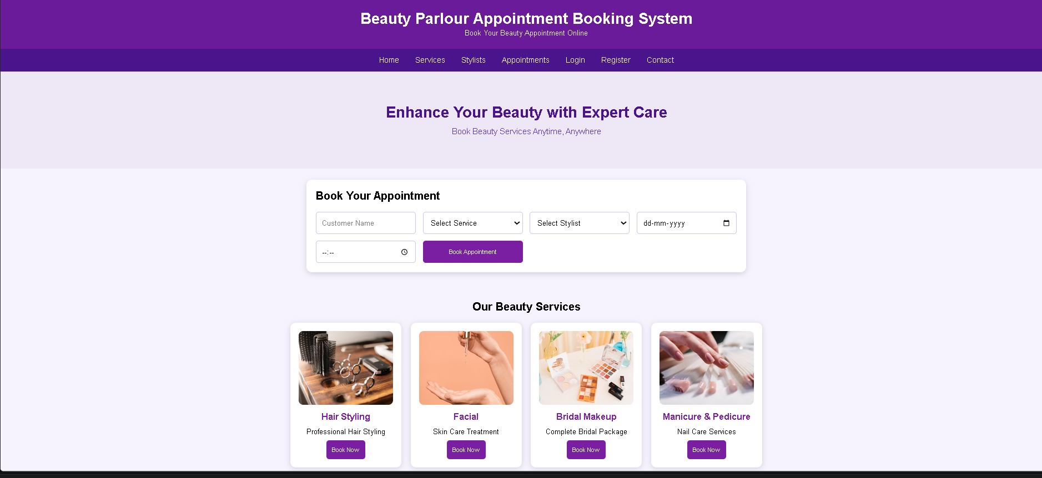

EXPERIMENT-8:
<!DOCTYPE html>
<html lang="en">
<head>
<meta charset="UTF-8">
<meta name="viewport" content="width=device-width, initial-scale=1.0">
<title>MedCare Hospital Appointment Booking</title>

<style>
*{
margin:0;
padding:0;
box-sizing:border-box;
font-family:Arial, sans-serif;
}

body{
background:#eef5fb;
}

header{
background:#0d6efd;
color:white;
text-align:center;
padding:25px;
}

nav{
background:#0b5ed7;
padding:15px;
text-align:center;
position:sticky;
top:0;
}

nav a{
color:white;
text-decoration:none;
margin:15px;
font-size:17px;
}

nav a:hover{
color:#ffd54f;
}

.hero{
background:#dbeafe;
padding:70px 20px;
text-align:center;
}

.hero h1{
color:#0b5ed7;
margin-bottom:10px;
}

.hero p{
color:#1e3a8a;
font-size:18px;
}

.search{
width:90%;
max-width:950px;
margin:25px auto;
background:white;
padding:20px;
border-radius:12px;
box-shadow:0 4px 12px rgba(0,0,0,0.15);
}

form{
display:grid;
grid-template-columns:repeat(auto-fit,minmax(180px,1fr));
gap:15px;
}

input,select{
padding:12px;
font-size:15px;
border:1px solid #cbd5e1;
border-radius:6px;
}

button{
background:#0d6efd;
color:white;
border:none;
padding:12px;
border-radius:6px;
cursor:pointer;
transition:0.3s;
}

button:hover{
background:#084298;
}

.section{
padding:35px;
}

.cards{
display:flex;
flex-wrap:wrap;
justify-content:center;
gap:20px;
}

.card{
width:240px;
background:white;
padding:18px;
border-radius:12px;
box-shadow:0 3px 10px rgba(0,0,0,0.15);
text-align:center;
transition:transform 0.3s;
}

.card:hover{
transform:translateY(-5px);
}

.card img{
width:100%;
height:180px;
object-fit:cover;
border-radius:10px;
margin-bottom:10px;
}

.card h3{
color:#0d6efd;
margin-bottom:8px;
}

.card p{
margin-bottom:6px;
}

textarea{
width:100%;
max-width:700px;
padding:12px;
border:1px solid #cbd5e1;
border-radius:8px;
}

.section ul{
line-height:2;
padding-left:20px;
}

footer{
background:#0b5ed7;
color:white;
text-align:center;
padding:18px;
margin-top:20px;
}
</style>
</head>

<body>

<header>
<h1>MedCare Hospital Appointment Booking System</h1>
<p>Book Doctor Appointments Online</p>
</header>

<nav>
<a href="#">Home</a>
<a href="#">Hospitals</a>
<a href="#">Doctors</a>
<a href="#">Appointments</a>
<a href="#">Login</a>
<a href="#">Register</a>
<a href="#">Contact</a>
</nav>

<section class="hero">
<h1>Find the Right Doctor for Your Health</h1>
<p>Search Hospitals and Book Appointments Easily</p>
</section>

<div class="search">
<h2>Search Doctor</h2>
<br>

<form>
<input type="text" placeholder="Enter Location">

<select>
<option>Select Specialty</option>
<option>Cardiologist</option>
<option>Dermatologist</option>
<option>Orthopedic</option>
<option>Pediatrician</option>
<option>Neurologist</option>
</select>

<input type="date">

<button type="submit">Search</button>
</form>
</div>

<section class="section">
<h2 align="center">Available Doctors</h2>
<br>

<div class="cards">

<div class="card">
<img src="https://images.pexels.com/photos/5327585/pexels-photo-5327585.jpeg?auto=compress&cs=tinysrgb&w=400" alt="Dr. John Smith">
<h3>Dr. John Smith</h3>
<p>Cardiologist</p>
<p>City Hospital</p>
<button>Book Appointment</button>
</div>

<div class="card">
<img src="https://images.pexels.com/photos/5214997/pexels-photo-5214997.jpeg?auto=compress&cs=tinysrgb&w=400" alt="Dr. Priya Sharma">
<h3>Dr. Priya Sharma</h3>
<p>Dermatologist</p>
<p>MedCare Hospital</p>
<button>Book Appointment</button>
</div>

<div class="card">
<img src="https://images.pexels.com/photos/5452293/pexels-photo-5452293.jpeg?auto=compress&cs=tinysrgb&w=400" alt="Dr. David Lee">
<h3>Dr. David Lee</h3>
<p>Orthopedic</p>
<p>Sunrise Hospital</p>
<button>Book Appointment</button>
</div>

<div class="card">
<img src="https://images.pexels.com/photos/5998470/pexels-photo-5998470.jpeg?auto=compress&cs=tinysrgb&w=400" alt="Dr. Anjali Rao">
<h3>Dr. Anjali Rao</h3>
<p>Pediatrician</p>
<p>LifeCare Hospital</p>
<button>Book Appointment</button>
</div>

</div>
</section>

<section class="section">
<h2>Patient Features</h2>
<ul>
<li>✔ Signup / Login</li>
<li>✔ Search Doctors by Specialty</li>
<li>✔ Search Hospitals by Location</li>
<li>✔ Book Appointment</li>
<li>✔ Cancel Appointment</li>
<li>✔ Appointment History</li>
<li>✔ View Appointment Status</li>
<li>✔ Update Personal Details</li>
<li>✔ View Hospital Location</li>
<li>✔ Rate and Review Doctors</li>
</ul>
</section>

<section class="section">
<h2>Hospital Features</h2>
<ul>
<li>✔ Hospital Registration</li>
<li>✔ Hospital Login</li>
<li>✔ Create Hospital Profile</li>
<li>✔ Update Hospital Details</li>
<li>✔ Manage Doctors</li>
<li>✔ Manage Appointments</li>
</ul>
</section>

<section class="section">
<h2>Administrator Features</h2>
<ul>
<li>✔ Manage Doctors</li>
<li>✔ Manage Appointments</li>
<li>✔ Appointment Statistics</li>
<li>✔ Rating Details</li>
<li>✔ Manage Hospitals</li>
<li>✔ Manage Patients</li>
</ul>
</section>

<section class="section">
<h2>Patient Feedback</h2>
<textarea rows="5" placeholder="Write your review here..."></textarea>
<br><br>
<button>Submit Review</button>
</section>

<section class="section">
<h2>Contact Us</h2>
<p><b>Email:</b> support@medcarehospital.com</p>
<p><b>Phone:</b> +1 9876543210</p>
<p><b>Address:</b> MedCare Hospital, Main City</p>
</section>

<footer>
<p>© 2026 MedCare Hospital Appointment Booking System | All Rights Reserved</p>
</footer>

</body>
</html>
OUTPUT:
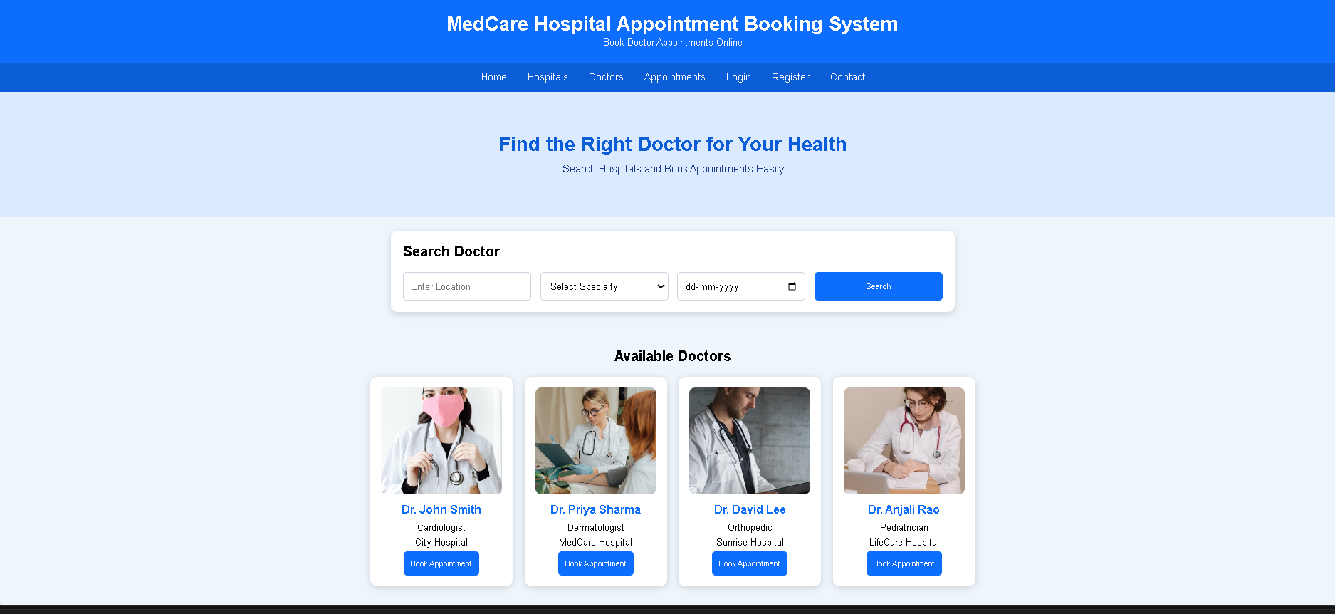

EXPERIMENT-9:
<!DOCTYPE html>
<html lang="en">
<head>
<meta charset="UTF-8">
<meta name="viewport" content="width=device-width, initial-scale=1.0">
<title>TechSavvy Online Shopping</title>

<style>
*{
margin:0;
padding:0;
box-sizing:border-box;
font-family:Arial, sans-serif;
}

body{
background:#eef3f8;
}

header{
background:#0b1f3a;
color:white;
text-align:center;
padding:25px;
}

nav{
background:#133b6b;
text-align:center;
padding:15px;
}

nav a{
color:white;
text-decoration:none;
margin:15px;
font-size:17px;
}

nav a:hover{
color:#ffd54f;
}

.hero{
background:#dbeafe;
text-align:center;
padding:70px 20px;
}

.hero h1{
color:#0b1f3a;
margin-bottom:10px;
}

.hero p{
color:#1e3a8a;
font-size:18px;
}

.search{
width:90%;
max-width:1000px;
background:white;
margin:25px auto;
padding:20px;
border-radius:12px;
box-shadow:0 4px 12px rgba(0,0,0,0.15);
}

form{
display:grid;
grid-template-columns:repeat(auto-fit,minmax(180px,1fr));
gap:15px;
}

input,select{
padding:12px;
border:1px solid #ccc;
border-radius:8px;
}

button{
background:#0b5ed7;
color:white;
border:none;
padding:12px;
border-radius:8px;
cursor:pointer;
}

button:hover{
background:#084298;
}

.section{
padding:40px 20px;
}

.section h2{
text-align:center;
color:#133b6b;
margin-bottom:30px;
}

.cards{
display:grid;
grid-template-columns:repeat(auto-fit,minmax(220px,1fr));
gap:25px;
max-width:1100px;
margin:auto;
}

.card{
background:white;
border-radius:15px;
overflow:hidden;
box-shadow:0 5px 15px rgba(0,0,0,0.12);
transition:0.3s;
text-align:center;
}

.card:hover{
transform:translateY(-6px);
}

.card img{
width:100%;
height:180px;
object-fit:cover;
}

.card h3{
color:#0b5ed7;
margin:15px 0 8px;
}

.card p{
margin-bottom:15px;
}

.card button{
margin-bottom:18px;
}

.features{
max-width:1000px;
margin:auto;
display:grid;
grid-template-columns:1fr 1fr;
gap:25px;
}

.feature-box{
background:white;
padding:25px;
border-radius:15px;
box-shadow:0 4px 12px rgba(0,0,0,0.12);
}

.feature-box h3{
color:#133b6b;
margin-bottom:15px;
}

.feature-box ul{
line-height:2;
padding-left:20px;
}

.review{
max-width:800px;
margin:auto;
text-align:center;
}

.review textarea{
width:100%;
padding:15px;
border:1px solid #ccc;
border-radius:10px;
margin-bottom:15px;
}

.contact{
text-align:center;
line-height:2;
}

footer{
background:#0b1f3a;
color:white;
text-align:center;
padding:20px;
margin-top:30px;
}

@media(max-width:768px){
.features{
grid-template-columns:1fr;
}
}
</style>
</head>

<body>

<header>
<h1>TechSavvy Online Shopping</h1>
<p>Electronics Shopping Made Easy</p>
</header>

<nav>
<a href="#">Home</a>
<a href="#">Products</a>
<a href="#">Categories</a>
<a href="#">Cart</a>
<a href="#">Wishlist</a>
<a href="#">Login</a>
<a href="#">Register</a>
<a href="#">Contact</a>
</nav>

<section class="hero">
<h1>Latest Electronic Gadgets</h1>
<p>Smartphones • Laptops • Tablets • Accessories</p>
</section>

<div class="search">
<h2>Search Products</h2>
<br>

<form>
<input type="text" placeholder="Search Product">

<select>
<option>All Categories</option>
<option>Smartphones</option>
<option>Laptops</option>
<option>Tablets</option>
<option>Headphones</option>
<option>Smart Watches</option>
</select>

<select>
<option>Price Range</option>
<option>Under $100</option>
<option>$100 - $500</option>
<option>$500 - $1000</option>
<option>Above $1000</option>
</select>

<button type="submit">Search</button>
</form>
</div>

<section class="section">
<h2>Popular Products</h2>

<div class="cards">

<div class="card">
<img src="https://images.pexels.com/photos/607812/pexels-photo-607812.jpeg?auto=compress&cs=tinysrgb&w=400" alt="Smartphone">
<h3>Smartphone</h3>
<p><strong>Price: $699</strong></p>
<button>Add to Cart</button>
</div>

<div class="card">
<img src="https://images.pexels.com/photos/18105/pexels-photo.jpg?auto=compress&cs=tinysrgb&w=400" alt="Laptop">
<h3>Laptop</h3>
<p><strong>Price: $999</strong></p>
<button>Add to Cart</button>
</div>

<div class="card">
<img src="https://images.pexels.com/photos/1334597/pexels-photo-1334597.jpeg?auto=compress&cs=tinysrgb&w=400" alt="Tablet">
<h3>Tablet</h3>
<p><strong>Price: $499</strong></p>
<button>Add to Cart</button>
</div>

<div class="card">
<img src="https://images.pexels.com/photos/3394650/pexels-photo-3394650.jpeg?auto=compress&cs=tinysrgb&w=400" alt="Wireless Headphones">
<h3>Wireless Headphones</h3>
<p><strong>Price: $149</strong></p>
<button>Add to Cart</button>
</div>

</div>
</section>

<section class="section">
<div class="features">

<div class="feature-box">
<h3>Customer Features</h3>
<ul>
<li>User Registration & Login</li>
<li>Search Products</li>
<li>Browse Categories</li>
<li>Check Product Availability</li>
<li>View Product Details</li>
<li>Add to Cart</li>
<li>Wishlist</li>
<li>Checkout & Order Tracking</li>
</ul>
</div>

<div class="feature-box">
<h3>Administrator Features</h3>
<ul>
<li>Admin Login</li>
<li>Add & Remove Products</li>
<li>Update Prices & Descriptions</li>
<li>Manage Categories</li>
<li>View Customer Orders</li>
<li>Generate Reports</li>
<li>Inventory Management</li>
</ul>
</div>

</div>
</section>

<section class="section review">
<h2>Customer Reviews</h2>
<textarea rows="5" placeholder="Write your review here..."></textarea>
<br>
<button>Submit Review</button>
</section>

<section class="section contact">
<h2>Contact Us</h2>
<p><strong>Email:</strong> support@techsavvy.com</p>
<p><strong>Phone:</strong> +1 9876543210</p>
<p><strong>Address:</strong> TechSavvy Electronics Store</p>
</section>

<footer>
<p>© 2026 TechSavvy Online Shopping | All Rights Reserved</p>
</footer>

</body>
</html>
OUTPUT:
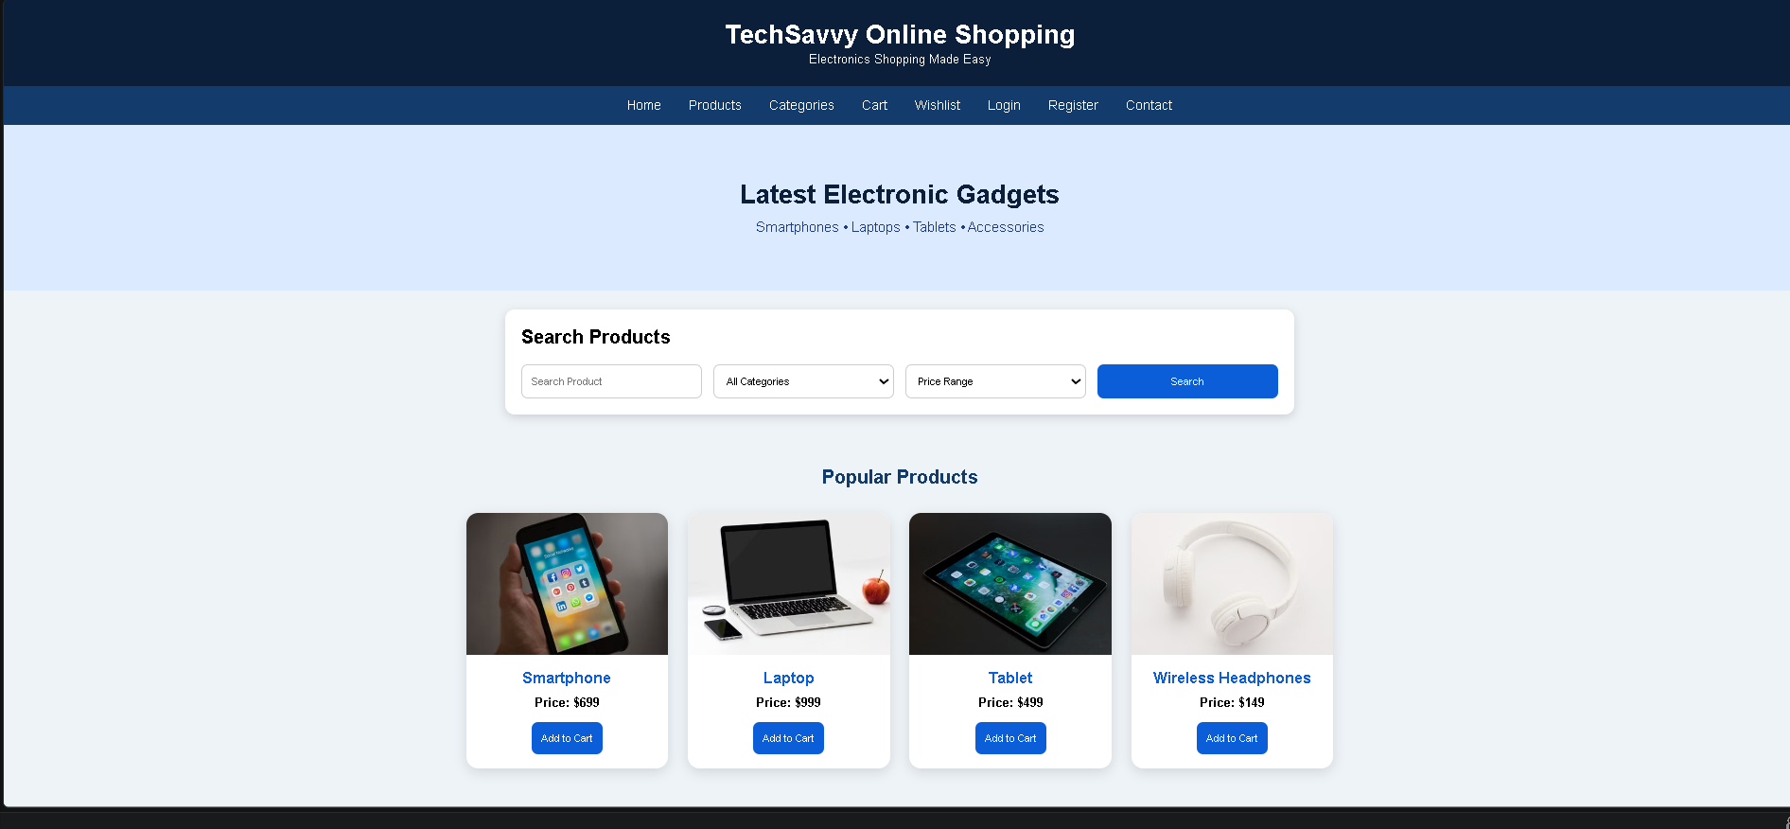

EXPERIMENT-10:

<!DOCTYPE html>
<html lang="en">
<head>
<meta charset="UTF-8">
<meta name="viewport" content="width=device-width, initial-scale=1.0">
<title>StyleHub - Online Fashion Store</title>

<style>
*{
margin:0;
padding:0;
box-sizing:border-box;
font-family:Arial, Helvetica, sans-serif;
}

body{
background:#f8f5fb;
color:#333;
}

header{
background:#6a1b9a;
color:white;
text-align:center;
padding:25px;
}

nav{
background:#4a148c;
text-align:center;
padding:15px;
position:sticky;
top:0;
}

nav a{
color:white;
text-decoration:none;
margin:15px;
font-size:17px;
}

nav a:hover{
color:#ffd54f;
}

.hero{
background:#ede7f6;
text-align:center;
padding:70px 20px;
}

.hero h1{
color:#4a148c;
font-size:38px;
margin-bottom:10px;
}

.hero p{
color:#6a1b9a;
font-size:18px;
}

.search-box{
width:90%;
max-width:1000px;
margin:30px auto;
background:white;
padding:25px;
border-radius:15px;
box-shadow:0 5px 15px rgba(0,0,0,0.15);
}

.search-box h2{
color:#4a148c;
margin-bottom:15px;
}

form{
display:grid;
grid-template-columns:repeat(auto-fit,minmax(180px,1fr));
gap:15px;
}

input,select{
padding:12px;
border:1px solid #ccc;
border-radius:8px;
font-size:15px;
}

button{
background:#8e24aa;
color:white;
border:none;
padding:12px;
border-radius:8px;
cursor:pointer;
transition:0.3s;
}

button:hover{
background:#4a148c;
}

.section{
padding:40px 20px;
}

.section h2{
text-align:center;
color:#4a148c;
margin-bottom:30px;
}

.cards{
display:grid;
grid-template-columns:repeat(auto-fit,minmax(220px,1fr));
gap:25px;
max-width:1100px;
margin:auto;
}

.card{
background:white;
border-radius:15px;
overflow:hidden;
box-shadow:0 5px 15px rgba(0,0,0,0.12);
transition:transform 0.3s;
text-align:center;
}

.card:hover{
transform:translateY(-8px);
}

.card img{
width:100%;
height:250px;
object-fit:cover;
}

.card-content{
padding:18px;
}

.card h3{
color:#8e24aa;
margin-bottom:10px;
}

.card p{
margin-bottom:15px;
}

.features{
max-width:1100px;
margin:auto;
display:grid;
grid-template-columns:1fr 1fr;
gap:25px;
}

.feature-box{
background:white;
padding:25px;
border-radius:15px;
box-shadow:0 5px 12px rgba(0,0,0,0.12);
}

.feature-box h3{
color:#6a1b9a;
margin-bottom:15px;
}

.feature-box ul{
line-height:2;
padding-left:20px;
}

.review{
max-width:800px;
margin:auto;
text-align:center;
}

.review textarea{
width:100%;
padding:15px;
border:1px solid #ccc;
border-radius:10px;
margin-bottom:15px;
}

.contact{
text-align:center;
line-height:2;
}

footer{
background:#4a148c;
color:white;
text-align:center;
padding:20px;
margin-top:30px;
}

@media(max-width:768px){
.features{
grid-template-columns:1fr;
}
}
</style>
</head>

<body>

<header>
<h1>StyleHub Fashion Store</h1>
<p>Shop the Latest Fashion Trends</p>
</header>

<nav>
<a href="#">Home</a>
<a href="#">Men</a>
<a href="#">Women</a>
<a href="#">Kids</a>
<a href="#">Accessories</a>
<a href="#">Cart</a>
<a href="#">Wishlist</a>
<a href="#">Login</a>
<a href="#">Register</a>
</nav>

<section class="hero">
<h1>Fashion for Everyone</h1>
<p>Clothing • Footwear • Accessories</p>
</section>

<div class="search-box">
<h2>Search Products</h2>

<form>
<input type="text" placeholder="Search Product">

<select>
<option>Select Category</option>
<option>Men</option>
<option>Women</option>
<option>Kids</option>
<option>Accessories</option>
</select>

<select>
<option>Select Price</option>
<option>Under $50</option>
<option>$50 - $100</option>
<option>$100 - $200</option>
<option>Above $200</option>
</select>

<button type="submit">Search</button>
</form>
</div>

<section class="section">
<h2>Popular Categories</h2>

<div class="cards">

<div class="card">
<img src="https://images.pexels.com/photos/1043474/pexels-photo-1043474.jpeg?auto=compress&cs=tinysrgb&w=400" alt="Men's Wear">
<div class="card-content">
<h3>Men's Wear</h3>
<p>Casual & Formal Collection</p>
<button>Shop Now</button>
</div>
</div>

<div class="card">
<img src="https://images.pexels.com/photos/994523/pexels-photo-994523.jpeg?auto=compress&cs=tinysrgb&w=400" alt="Women's Wear">
<div class="card-content">
<h3>Women's Wear</h3>
<p>Latest Fashion Trends</p>
<button>Shop Now</button>
</div>
</div>

<div class="card">
<img src="https://images.pexels.com/photos/1620760/pexels-photo-1620760.jpeg?auto=compress&cs=tinysrgb&w=400" alt="Kids Fashion">
<div class="card-content">
<h3>Kids Fashion</h3>
<p>Comfortable & Stylish</p>
<button>Shop Now</button>
</div>
</div>

<div class="card">
<img src="https://images.pexels.com/photos/934070/pexels-photo-934070.jpeg?auto=compress&cs=tinysrgb&w=400" alt="Accessories">
<div class="card-content">
<h3>Accessories</h3>
<p>Bags, Watches & More</p>
<button>Shop Now</button>
</div>
</div>

</div>
</section>

<section class="section">
<div class="features">

<div class="feature-box">
<h3>Customer Features</h3>
<ul>
<li>User Registration & Login</li>
<li>Browse Products</li>
<li>Search & Filter Products</li>
<li>View Product Details</li>
<li>Shopping Cart</li>
<li>Wishlist</li>
<li>Secure Checkout</li>
<li>Track Orders</li>
<li>Order History</li>
<li>Returns & Exchange</li>
</ul>
</div>

<div class="feature-box">
<h3>Administrator Features</h3>
<ul>
<li>Admin Login</li>
<li>Add & Remove Products</li>
<li>Update Prices</li>
<li>Manage Categories</li>
<li>Manage Customer Orders</li>
<li>Customer Management</li>
<li>Discount & Offer Management</li>
<li>Sales Reports</li>
</ul>
</div>

</div>
</section>

<section class="section review">
<h2>Customer Reviews</h2>
<textarea rows="5" placeholder="Write your review here..."></textarea>
<br>
<button>Submit Review</button>
</section>

<section class="section contact">
<h2>Contact Us</h2>
<p><strong>Email:</strong> support@stylehub.com</p>
<p><strong>Phone:</strong> +1 9876543210</p>
<p><strong>Address:</strong> StyleHub Fashion Store</p>
</section>

<footer>
<p>© 2026 StyleHub Online Fashion Store | All Rights Reserved</p>
</footer>

</body>
</html>
OUTPUT:
